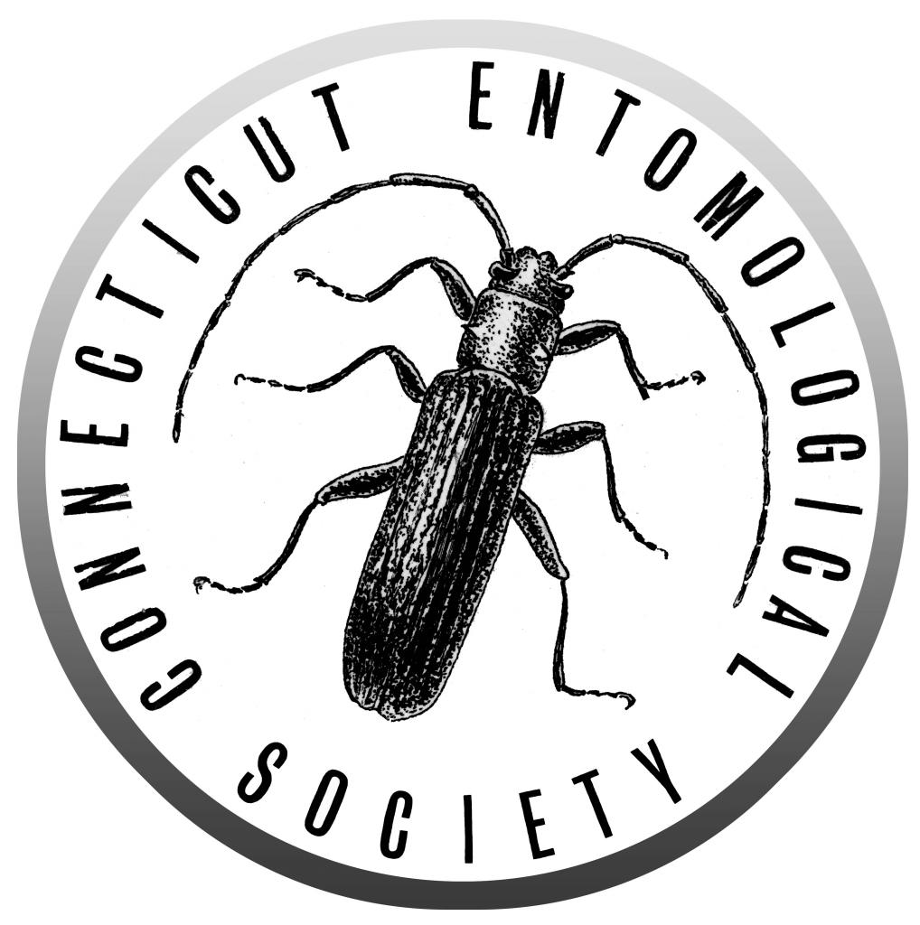
Minutes from the 546th Meeting of the Connecticut
Entomological Society
November 16th 2018

Connecticut Agriculture Experiment Station

Dinner was provided at the meeting location

Business meeting: President Raymond Simpson called the meeting to order at approximately 7:30 PM

Reports: Minutes from the 545th meeting were presented by Secretary Katherine Taylor and approved as read.

An overview of the treasurer’s report was read by President Raymond Simpson and approved.

Old Business:
- The website is up and running again.

New Business:
- No December meeting for the holidays
- March 15th meeting moved to March 8th
- April 19th meeting moved to April 12th at the Agriculture station

Announcements:
- 17 members and 12 guests attended the meeting
- The next meeting in January will be at Yale. Steve Trumbo will present about burying beetles.

Exhibits:
- Stan Malcom brought entomology books from the Book Barn
- Raul Ferraira pamphlets about endangered pollinators
- Ray Simpson brought pinned moths.

Evening Presentation:
Dr. Richard Cowles from the Connecticut Agricultural Experiment Station presented his work on improving the genetics of honey bees. Queen bee improvement is important because she determines genetics for entire colony. Bee colony survival over the winter is decreased by parasitic varroa mites, which transmit viruses to the colony. However, hygienic behaviors of the colony and behaviors attacking varroa mites can decrease mite numbers and thus increase the survival of the colony. After a bee keeper’s colony is loss over the winter due to viral infection, replacement bees bought from southern states are shipped with mites and other pests and are likely to die again next year.
He presented his work trapping bees from wild colonies that survive the winter despite varroa mites to assess if Connecticut’s feral bees may serve as a genetic resource for a breeding program. Swarm traps successfully captured wild colonies in Connecticut, which seem to be surviving the winter. However their genetics may not be superior to domesticated bees as observed parasitism rate was high. Found colonies in structures may be good alternate source for high quality genetics that will be investigated further in the future.
Additionally he presented his work assessing queen bees from a variety of selective breeding programs. He found a variety of traits across these sources including variation in aggressiveness, honey production, and mite resistance, but no source was ideal for all traits. Also he discussed his queen rearing project. He removed queen and eggs and larvae from colony then graft in larvae to be developed into queens. The new queens are then placed in mini mating nucs with nurse bees. After several weeks mating with drones. Production requires significant time and equipment, but passing to commercial honey producers would not work because producing queens would take away from honey production. Bee keepers can identify excess queen cells they would remove for normal swarm prevention, and use those. He then discussed best practices including nucleus back up colonies, preventing swarming by splitting, removing poor queens, requeen when mite treatment required, and finally recognizing that loosing colonies is a good thing a it removed bad genetics.

Note: corrections and additions to the minutes are welcomed. Please email ctentsoc@gmail.com.

