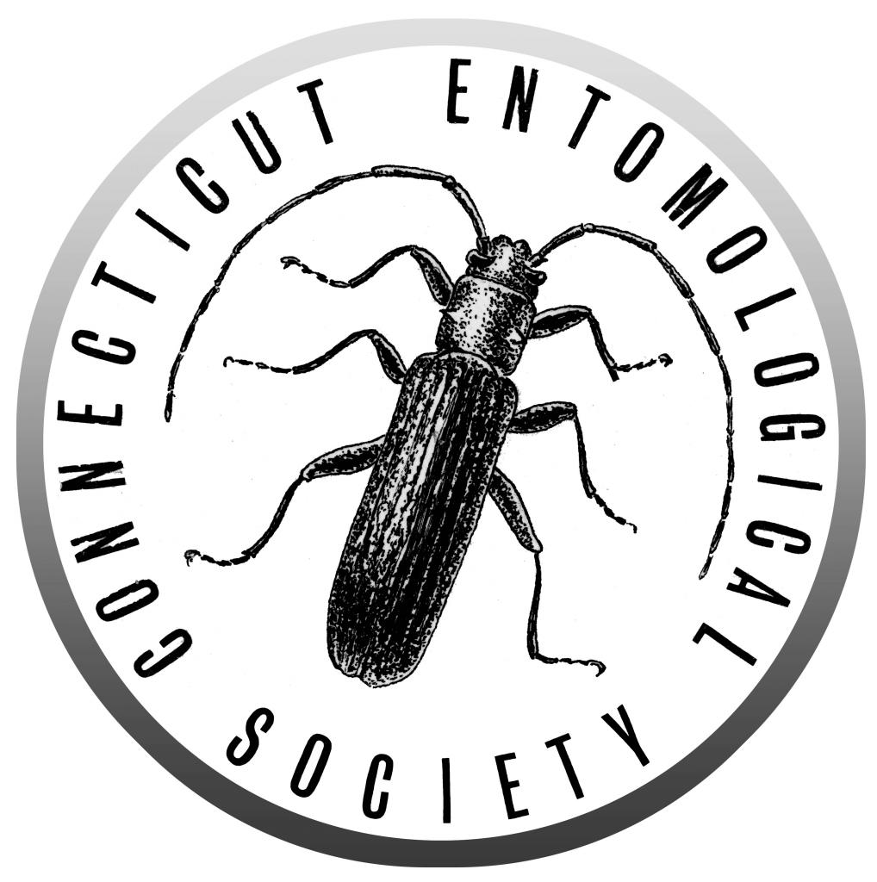
Minutes from the 555th Meeting of the Connecticut
Entomological Society
January 17th 2020

University of Connecticut

Pizza dinner was provided in the UConn biophysics lobby at 6:30 PM

Business meeting: President Raymond Simpson called the meeting to order at approximately 7:30 16 members and 3 guests were present.

Reports: Minutes from the prior meeting were posted on the website and approved by the society.

The treasurer’s report was read by President Raymond Simpson and approved.

Old Business:
- None
New Business:
- New EntSoc caps have been ordered and should be available for purchase in February
- Student competition next month still looking for interested students.
- 3 members volunteered for the student competition judges
- A new secretary is needed for next year as Katie is moving out of state
Announcements:
- CT wild bee checklist project
- Yale Peabody art course
- Feb 21 Student Symposium
- March 20 Activity
- April 17 Robert GeGear
- May collecting trip

Exhibits:
- Stan Malcom pamphlet with his airline trail photos
- Ray Simpson brought new tiger beetle book from Pearson

Evening Presentation:
Note: corrections and additions to the minutes are welcomed. Please email ctentsoc@gmail.com.

