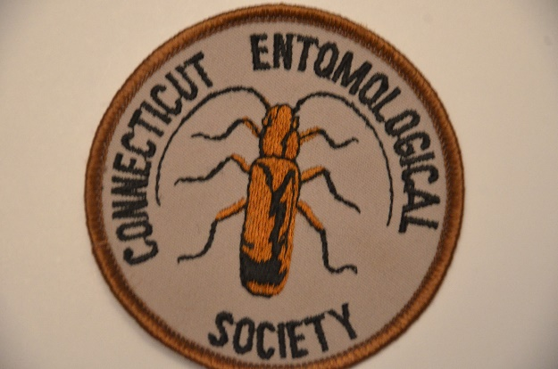
Minutes of
CES 565th Meeting (Virtual via Zoom), 15 October, 2021
(Leonard E. Munstermann, acting secretary)
Pre-Meeting, Informal, 18:30-19:30
--Lucas Keras showed a newly emerged Polyphemus moth he has reared. He noted that the Saturniidae moths were not very active during this period. He showed a moth trap with bait and lateral slots. On evening 14 October, using rotten strawberries as bait, he trapped 15 moths.
--Raymond Simpson, using light sheet, collected mostly Caddis flies, at Sleeping Giant Park.
--Michele Sorenson has reared the milkweed bug, Oncopeltus fasciatus, on milkweed seeds.
--The Zale moth, Z. lunata, was noted as common during this fall season.

Business Meetng, 19:30-19:55
--Meeting was called to order by President Raymond Simpson, promptly at 19:30. Thirty-five (35) members were in attendance, along with 34 guests. The latter included 8 members of the Connecticut Butterfly Association, along with 12 Middle School students of CES member, Brigette Zacharczenko.
--Treasurer’s report was presented by Michael Montgomery. He noted that the annual membership dues are due for the September-August 2021-2011 year. Only 13 members have paid to date; formal reminders will be sent.
--Old Business:
(1) The autumn meetings will continue virtually through Zoom.
(2) President Simpson noted that CES merchandise was available for saie. Items include T-shirts and caps with the CES logo.
--New Business:
(1) The annual insect photo competition was announced. Selected photos will be used to construct the CES calendar. Insect (arthropod) photos must be taken within the past 3 years, preferably of Connecticut insects, and judged on the basis of focus, color composition and theme. Submissions are to be from members or guests, and personally photographed.

(2) President Simpson announced the organization of a summer BioBlitz 3-4 June, 2022. It will be held at Avery Point, Groton; insects will be accepted if collected within an 11-mile radius. Institutional participation includes University of Connecticut’s Marine Sciences Institute, DEEP Fisheries, U. Connecticut’s Dept of Ecology and Evolutionary Biology, Connecticut College Arboretum, and the Connecticut Museum of Natural History.
(3) President Simpson is spearheading an effort to engage CES members with iNaturalist projects that will provide a local and state database of insect photos, with identifications. He showed exampes of photos along with summary statistics this program produces.
(4) The next meeting will be held 19 November, 2021, with speaker Mattheau Comerford.
--The meeting was adjourned at 19:55.

The Evening Speaker
Speaker: Dr. Douglas Tallamy
Talk Title: A Guide to Restoring the Little Things that Run the World.
Talk Summary: A recent UN report predicts that as many as 1 million species will disappear from planet earth because of human activities. Many of these are insects and nearly all species at risk rely on insects. Insects have already declined 45% since 1974. The most alarming part of this statistic is that we don’t seem to care, despite the fact that a world without insects is a world without humans! So how do we create beautiful landscapes brimming with life; landscapes that support the pollinators, herbivores, detritivores, predators and parasitoids that run the ecosystems we depend on? Tallamy will remind us of the many essential roles insects play, and describe the simple changes we must make in our landscapes and our attitudes to keep insects on the ground, in the air and yes, on our plants.
Questions and discussion followed the presentation.

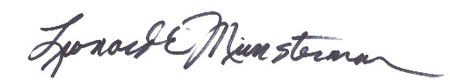
Submitted:
Leonard E. Munstermann, acting secretary
19 November, 2021

